Title here – O artigo pode ser escrito em lingua portuguesa ou em lingua inglesa
FIRST AUTHOR
University Department, University Name, Address
City, Countr, e-mail address
SECOND AUTHOR
Group, Laboratory, Address
City, Countr, e-mail address
This is where the abstract should be placed. It should consist of one paragraph giving a concise summary of the material in the article below. Replace the title, authors, and addresses with your own title, authors, and addresses. You may have as many authors and addresses as you like. It is preferable not to use footnotes in the abstract or the title; the acknowledgments of funding bodies etc. are to be placed in a separate section at the end of the text.

Guidelines
Please use the following instructions (MAXIMUM TEXT LENGTH – 10 PAGES):

Topics
The topics accepted to this issue are: (i) "The evolution of the atmospheric sciences and the Hydrosphere in the last two decades and the challenges ahead"; (ii) "Developments in Solid Earth in the last two decades and the challenges ahead"; (iii) "The Evolution of the Scientific National in the last 20 years"; (iv) "The current status and future challenges of the National Scientific System".

Using MS-Word
You can delete our sample text and replace it with the text of your own contribution to the proceedings. However we recommend that you keep an initial version of this file for reference.
Page numbers are included at the top of the page for your guidance. The final pagination of the volume will be done by the Publisher.
The text should be set in 10 pt roman with a leading (interline spacing) of 13 pt. Type the title of the paper in 11 pt boldface and in upper case. The 1st section heading is in 10 pt boldface, upper and lower case. The 2nd section heading is in 10 pt bold italic, upper and lower case. If there is a 3rd section heading then it should be 10 pt italic.
Authors’ names are set in 9 pt and in upper case. Addresses are in 9 pt italics. The abstract, figure and table captions should be in 8 pt.
It is also important to reproduce the spacing of the text and headings as shown here. Text should be slightly more than single-spaced; use a leading (which is the average distance from the base of one line of text to the base of an adjacent line) of 13 pt and 8 pt for footnotes. All headings should be separated from the text preceding it by a vertical space of about 12 pt and by 6 pt from the subsequent text.
Paragraphs should have its first line indented by about 0,63 cm except where the paragraph is preceded by a heading and the abstract should be indented on both sides by 0,63 cm from the main body of the text.

Headings, Text and Equations
Please preserve the style of the headings, text font and line spacing in order to provide a uniform style for the proceedings volume.
Equations should be centered and numbered consecutively, as in Eq. (1). An alternative method is given in Eq. (2) for long sets of equations where only one referencing equation number is wanted.

Tables
It does not matter how you choose to place the inner lines of the table, but we would prefer the border lines to be of the style shown in Table 1. For the inner lines of the table, it looks better if they are kept to a minimum.
The caption heading for a table should be placed at the top of the table.

Table 1. First five normalized natural frequencies of a clamped beam with internal hinge at 4 different locations.
 | A = 0.56 | B = 0.69 | C = 0.75 | D = 0.100
AB₁ | 14.0640 | 18.5620 | 22.0817 | 18.90732
AC₂ | 61.6728 | 44.7844 | 44.5884 | 60.17496
AD₃ | 88.1380 | 118.1564 | 101.2240 | 120.72693
DB₄ | 199.8594 | 173.1269 | 194.4907 | 188.75258

Figures/Illustrations
It is best to embed the figures in the text where they are first cited, e.g. see Figure 1. Please ensure that all labels in the figures are legible regardless of whether they are drawn electronically or manually.

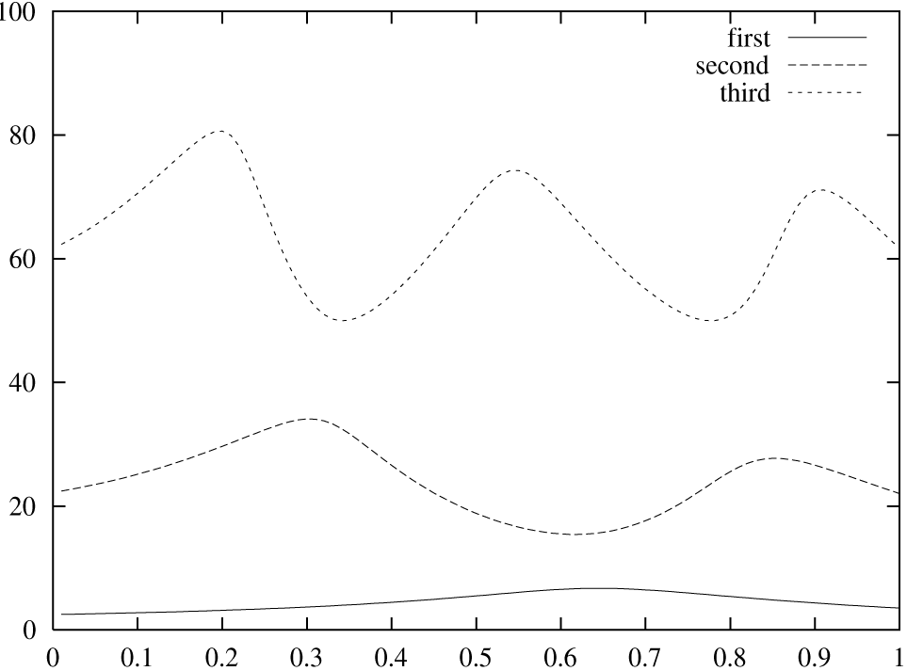

Figure 1. First 3 normalized frequencies versus release location
The caption heading for a figure should be placed below the figure.

Acknowledgments, Appendices, Footnotes and the Bibliography
If you wish to acknowledge funding bodies etc., the acknowledgments may be placed in a separate section at the end of the text, before the Appendices.
It is preferable not to have Appendices in a brief article, but if more than one Appendix is necessary then set headings as Appendix A, Appendix B etc.

Footnotes and the citation
Footnotes are denoted by a character superscript in the text,b and references are denoted by square brackets for citation e.g. [2] please note that the citation should appear before the punctuation mark, e.g. [2], in the body text.

Acknowledgments
This is where one acknowledge funding bodies etc.

Appendix
We can insert an Appendix here, which can also include equations which are numbered as, e.g., Eq. (A.1).
(A.1)
References
- M. Barranco and J. R. Buchler, Phys. Rev. Cf22, 1729 (1980).
- H. Müller and B. D. Serot, Phys. Rev. C52, 2072 (1995).
- V. Baran, M. Colonna, M. Di Toro and A. B. Larionov, Nucl. Phys. A632, 287 (1998)
- V. Baran, M. Colonna, M. Di Toro and V. Greco, Phys. Rev. Lett. 86, 4492 (2001).

b Just like this one.

